Talent Studio 4
Technical Overview
L. Zancani and Colleagues

Talent Studio 4 1
1. Introduction 2
2. Delivery Infrastructure 3
3. Application Overview 5
3.1. Implementation Technology 5
3.2. Deployment Architecture 5
3.3. Logical Application Architecture 6
3.4. Organisational Object Model 7
3.4.1. Persisting the Object Model 8
3.5. Users and Security 8
3.6. Portfolios 8
3.7. Questionnaire Engine 9
3.7.1. Questionnaires 9
3.7.2. Questionnaire Data Reporting 9
3.7.3. Appraisal Manager 10
3.8. Metrics and Reporting Engine 10
3.9. Talent Management Arenas 10
3.10. Integration Interface 10
4. Summary 11

Introduction

This document provides a high-level technical overview of both the Talent Studio 4 application itself and the technology platform used to deliver it.

Delivery Infrastructure

Talent Studio 4 is a hosted application securely delivered over the public internet using HTTP over SSL. It runs in the Oracle AS application server with the Oracle AS HTTP server and uses Oracle RDBMS for data persistence.

This is illustrated in the diagram below.

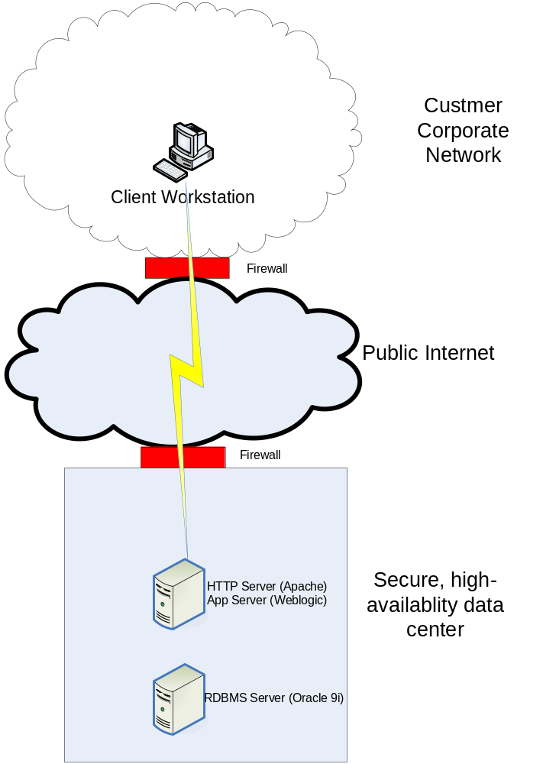
Figure 1 – Talent Studio 4 Delivery Infrastructure

The yellow link between the client and the web server represents HTTP over SSL (sometimes referred to as HTTPS). This is a way of strongly encrypting traffic between a web server and a client running a browser so that data traversing the link cannot be “snooped” or intercepted en-route to its destination.

The application servers themselves are housed in a state-of-the art data center providing 24/7 availability and extremely high levels of physical security.

In the case where integration between Talent Studio 4 and other enterprise applications (e.g. ERP systems) residing in the customer network is required, a persistent encrypted tunnel (e.g. LAN-LAN IPSec tunnel) would usually be set up to carry inter-application traffic. It should be noted however that the data transport mechanism in such projects is always considered on a case-by-case basis; simpler mechanisms often suffice.

Application Overview

This section provides a high-level view of the technology used to implement the application and the architecture of the application itself.

Implementation Technology

Talent Studio 4 is implemented in Java on the J2EE enterprise platform running in the Oracle AS Application server fronted by the Oracle web server. Oracle 9i is used to provide data persistence. Oracle DB and Oracle AS are all run on Linux.

JavaScript is used for some limited client-side processing.

These are proven, scalable, industry-standard technologies.

Deployment Architecture

Talent Studio 4 is a 3-tier application meaning that the presentation (front-end), business logic and data persistence areas of functionality are separated into three “layers”. This is important as it allows these areas of functionality to be modified independently of each other.

The layers are divided over two separate hosts in order to provide improved performance. This is illustrated in the figure below.

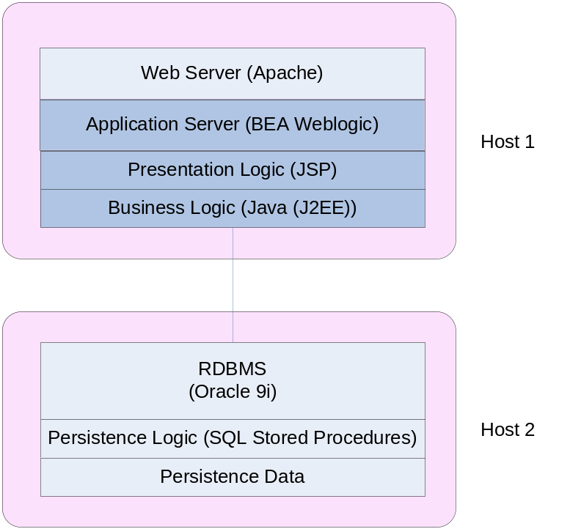
Figure 2 - Architectural separation over two hosts

Logical Application Architecture

At the highest level, Talent Studio 4 broadly consists of 6 components:

- Foundation Services (security, object persistence and intelligent search)
- Organisational Object Model
- Questionnaire Engine
- Metrics and Reporting Engine
- Talent Management Arenas
- Integration Interface (SOAP interface for connections to third party systems)

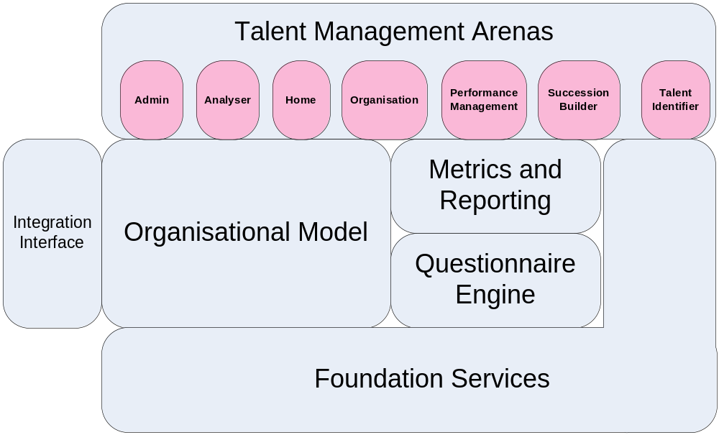
Figure 3 - Talent Studio 4 Logical Architecture

Foundation Services includes the security model, the object persistence layer and the interfaces to the embedded Autonomy IDOL server (used for concept-based searching).

The extensible organisational model encapsulates the individuals and organisational units in an organisation and the relationships between them. It provides this information to the other parts of Talent Studio 4.

The questionnaire engine manages the definition, distribution and collection of questionnaires. It makes use of the Oracle 9i Workflow engine.

The metrics and reporting engine has two central functions: diagnostics and measurement of the object model and reporting on questionnaire response data.

The Talent Management arenas are front-end views into the core application that are specialised for particular Talent Management activities. From the user’s perspective, they group together information and tools required for specific Talent Management activities and provide an intuitive, easy to use interface relevant to the user’s activities.

Broadly speaking, all the user interface elements of the applications are views of the object model, and user actions which affect the object model are executed through a controller layer between the object model and the arenas. This model-view-controller structure eases the addition of new functionality considerably by providing extremely loose coupling between the model and the task-driven user view of the application.

Organisational Object Model

Talent Studio 4’s model of an organisation is composed of three primary types of object: People, Positions and Organisational Units. Each of these object types has a core set of attributes but can be extended to add customer-defined attributes at implementation time.

People, Positions and Organisational Units are associated through primary and secondary associations representing the relationship between the real-world entities they represent.

An example of such a model is given in the figure below:

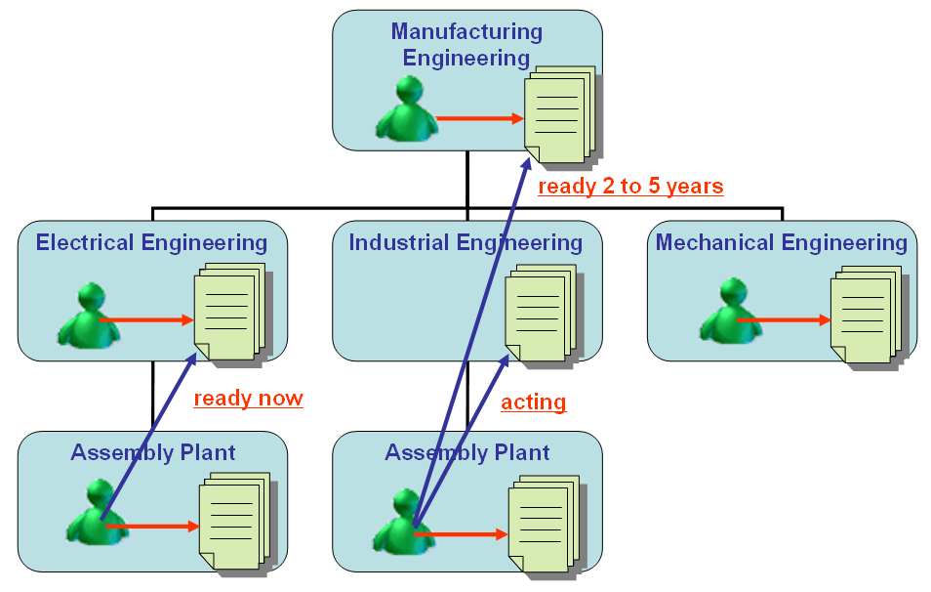
Figure 4 - Example Organisational Object Model Instance

In Figure 4, the blue rectangles represent organisational units, the head-and-shoulders figures represent People objects and the paper stacks represent position objects.

Positions have a containment relationship with organisational units (OUs), but subjects are associated with OUs only via their association with a position.

The red arrows in the diagram represent primary subject to position associations of type “current holder”.

The blue arrows represent user defined associations used in succession planning.

Persisting the Object Model
The object model is persisted using the high performance Hibernate framework (http://www.hibernate.org/) .

Users and Security

A fourth type of object defines users of Talent Studio. Typically each Person object defined in the system has a corresponding User, with associated login id and password. Users may also exist independent of People objects, usually for administrative users.

Every User is assigned a set of Roles which define the actions that the user may perform. For example, members of the HR team may be assigned the set of roles that given then full control over People and Positions in the Organisation, whereas department managers are only assigned the Role that allows them to edit details about existing People and Positions.

Additional security is provided by limiting the People and Positions that are visible to a user. By default, this is controlled by the location of the user’s associated Position within the organisation matrix. For example the Director of an Organisation unit will be able to see details his or her managers and all their subordinates. (I.e. everyone within the Organisation Unit). The managers will only be able to see details of their own direct reports.

In circumstances where this default visibility is not appropriate, Talent Studio can be configured to allow specified users access to selected parts of the Organisation structure. For example, users in the HR department may need access to everyone within the organisation, excluding the members of the board.

Portfolios

People and Position objects are associated with pools of data referred to as portfolios. Portfolios contain both unstructured (in the form of documents) and structured (in the form of questionnaire responses) data about the parent object. Documents may be in any format, including MS Word, MS Excel, MS PowerPoint and plain-text. For example, typically a portfolio item of type CV is created to be used to contain a person’s CV.

Once users have uploaded documents into People and Position portfolios, Talent Studios Document Search can be used to search documents by category, using concepts rather than just keywords.

Note that portfolio data is distinct from attribute values of the object.

Questionnaire Engine

Talent Studio 4 is able to collect data relevant to the Talent Management process by means of questionnaires.

A questionnaire is a named set of questions that can be associated with People. Users can answer these questions, and the results of such can be reported in a variety of formats. This functionality can be used to collect arbitrary data, but is also used to implement Talent Studio 4’s performance management capability.

Distribution of questionnaires and user notification of questionnaires that need to be answered is managed by the Oracle 9i workflow engine.

Questionnaires

Questionnaires are defined using XML files conforming to a schema. The schema specifies XML elements that represent the structure of a questionnaire, including question groupings and different types of question. The type of a question specifies which GUI element will be used to represent it when it is presented to a user for answering (e.g. radio buttons, drop-down menu, text box etc.).

Once a questionnaire definition has been created, its XML file is uploaded to Talent Studio, where it can be previewed. Subsequent amendments can be made to the questionnaire before publishing.

Talent Studio uses the XML definition to generate both a GUI representation of the questionnaire and a storage schema for persisting answers to the database.

The term questionnaire response is used to denote the set of answers provided by a particular user to a particular questionnaire.

Questionnaire Data Reporting

Talent Studio 4 supports two types of reports (Tabular lists and Cross-tabs), which can represent questionnaire data and data about person and position objects. All of these reports can be drilled-down into to show the data behind them.

Additionally, report data can be exported to CSV for import into other applications, e.g. Microsoft Excel.

Users can define and save populations to run reports against. A population is a subset of the people and/or positions visible to that user; specified by a series of selection criteria. These selection criteria may relate to anything contained or known by the object model (e.g. “All people with more than one emergency successor”),

When setting up a report, the user specifies the questionnaire questions to which the report pertains and the population to which it should apply.

Appraisal Manager

Talent Studio 4 provides an Appraisal Manager function supporting the automation of the performance appraisal process. This functionality allows administrators to define specialised questionnaires that are in the customer’s performance appraisal process. These can them be published to the subject of the appraisal, the subjects manager and a selection of peers.

Gathering of and reporting on performance appraisal data is carried out by the questionnaire and reporting engine.

Metrics and Reporting Engine

Since Talent Studio 4 is based around a model of the organisation, providing organisational metrics is a matter of measuring the object model.

Talent Studio 4’s metrics and reporting engine supports the definition of counts, mean averages and sums of any property of the object model or attribute of objects within the model.

These metrics can then be included in reports along with data taken directly from object attributes.

Talent Management Arenas

Each Talent Management Arena represents a group of tools and data views that are relevant to a particular area of Talent Management activity.

Arenas are essentially views into the object model, making the addition and/or modification of task-driven user activity extremely straight forward.

Each of these views is customisable so as to provide access to tools and data relevant to the customers needs.

Integration Interface

The Talent Studio Integration Interface provides a programmatic interface to the underlying organisational object model. This makes integration with arbitrary third party applications direct and simple.

The Integration Interface’s transport is SOAP over HTTPS.

Summary

Talent Studio 4 is an enterprise class application built around a 3-tier architecture. Internally, it is structured according as model-view-controller (MVC), providing low coupling between its constituent parts and high cohesion within those parts.

It is web-based and hosted in state-of-the-art data centre facilities.

Talent Studio 4 is implemented in Java and uses Sun Microsystems’s J2EE enterprise application framework. It runs in the industry-leading Oracle AS application server and is back-ended with Oracle 9i RDBMS.

